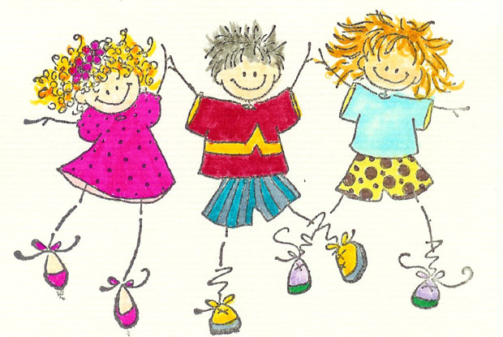
Grade 1 Weekly Overview
Sunday, Sept. 28 to Thursday, Oct.2
Homework for this week:
Spelling – available on the website
Oxford Reading Tree books that are sent home with your child – 15 minutes each night
English Language Arts homework – available on the website
Math – available on the website
What we are learning about this week: | Assessments this week:
English Language Arts  We are learning to…..  Writing & Grammar:  Write sentences with capital letters and full stops. Share feedback for editing and revising  Phonics: Associate the consonants h/ r/ m with the spelling of h/r/m words. Read words with the consonants h/r/m/  Listening and Reading Comprehension:  Share information orally. Use basic vocabulary for describing families. Ask for information. Discuss oral passages. Use a graphic organizer to take notes. Analyze sayings. Discuss the setting of a reading. Use setting to retell a reading. Write the setting of a reading  Vocabulary & Spelling Words: Understand and use basic vocabulary. Understand and read high-frequency words. Use basic vocabulary for describing what is around us at home and in our community.  Our Spelling Words: for,on,are,back,black,snack,picnic,fun  Mathematics  We are learning about…  - Numbers to 20  - Counting in 1s, 2s and 5s  - Comparing numbers to 20  - Before/After  - Tally Marks  - Introducing Number Stories  In our current Unit of Inquiry – Who We Are (includes Social Science, Mathematics and English Language Arts) we are learning about how…  Central Idea:  Communities are similar and different.  Lines of Inquiry:  - Communities we belong to  - How communities influence us  - Similarities and differences between people | English Language Arts:  Thursday, Oct. 2 – Spelling Test: for,on,are,back,black,snack,picnic,fun  Mathematics:  Thursday, Oct. 2 – Weekly Math Quiz (covering concepts learned in class)  Unit of Inquiry – Who We Are: Communities are similar and different  Ongoing assessments
 | Events
 | None for this week
 | Reminders
Please ensure your child arrives at school no later than 7:25 every day.

Please make sure your child’s teacher has your email address as this is our primary means of direct communication.

Remember to check your child’s schedule and send them with PE clothing on the appropriate days.

