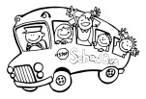GRADE ONE SCHOOL TRIP
Dear Parents,
We would like to inform you that our second Grade One field trip has been confirmed. We have been invited to Sheikh Zayed Sports City to learn all about healthy eating and exercise. The children will receive educational information about health and fitness and have the opportunity to play games with the sports team at the centre. This is a wonderful way to end our Unit of Inquiry about teams, leadership and cooperation. If you would like your child to attend the trip please complete the permission slip below and send 25 AED to cover the transportation cost.
The bus will leave school at 8.15 and return at 12.00.
A snack will be provided for those children who eat school lunches.

IMPORTANT INFORMATION:
Children MUST be at school at 7.30
Children MUST wear school P.E. clothes and trainers.
The permission slip MUST be signed and returned by Sunday 25th January.

Day | Classes
Sunday 1st February | Ms Caron, Ms Adri and Ms Brenda
Monday 2nd February | Ms Martina, Ms Denise and Ms Josephine
Wednesday 4th February | Ms Hope, Ms Maura, Ms Shannon and Ms Alexis

If you do not want your child to go on the trip please inform the class teacher. Your child can still attend school but will join another class that day.
Thank you.
Grade One Teacher’s.

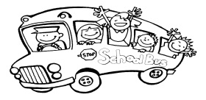

I (parents name) __________________________________________ give permission for

my child, (child’s name) _________________________ _______ to go on the school trip.

I enclose ____________ AED. Signed ___________________________Date __________

Emergency contact telephone number _______________________________________

