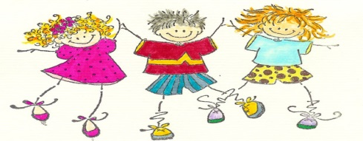
Grade 1 Weekly Overview
Sunday, Feb 22 to Thursday,Feb 26
Homework for this week:
Spelling – available on the website
Oxford Reading Tree books that are sent home with your child – 15 minutes each night
English Language Arts homework – available on the website
Math – available on the website
What we are learning about this week: | Assessments this week:
English Language Arts  We are learning to…..  Writing: Write narratives in which they recount two or more appropriately sequenced events, include some details regarding what happened, use temporal words to signal event order, and provide some sense of closure. Print all upper- and lowercase letters. Use verbs to convey a sense of past, present, and future  Phonics: focusing on the ‘ue’ sound  Listening and Reading Comprehension: 1) Ask and answer questions about key details in a text. 2) Identify the main topic and retell key details of a text. 3) Describe the connection between two individuals, events, ideas, or pieces of information in a text.  Vocabulary & Spelling Words: Understand and use basic vocabulary. Understand and read high-frequency words. Understand the general meaning of spoken language  Our Spelling Words: sit now find long box shop dance reflect  Mathematics  We are learning about…  - Place value- tens and ones  - Odd and Even Numbers  - Counting forwards/backwards on the number line  - Frames and Arrows  - Domino Addition  - Telling the time: Quarter to and Quarter past  - Subtraction  In our current Unit of Inquiry – How We Express Ourselves (includes Science, Mathematics and English Language Arts) we are learning about how…  Central Idea:  Light and sound can be used as a form of expression.  Lines of Inquiry:  - How light and sound is produced (causation)  - Properties of light and sound (form)  - Light and sound as a form of expression (change/causation) | English Language Arts: Spelling Test –Feb 26  Mathematics: Math Quiz  Unit of Inquiry – How we express ourselves
 | Events
 | Reminders
Please send in any toys or glow in the dark items related to light and/or sound with your child for the class to explore during our unit.

Please view our home page on the website for information on the following:

- Complete health vaccination forms
- Sign and return the page from the “Family Handbook” (if you have not already done so )

