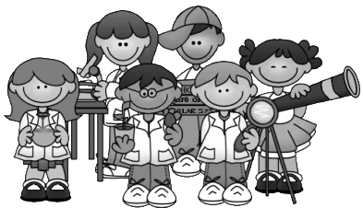

6 May 2015

Dear Parents

ENS LITTLE SCIENTIST SCIENCE FAIR 2015

We would like to invite your child to participate in the ENS Little Scientist Fair this year. Participation in the Science Fair is voluntary. The first round will be against the class and then the top two projects from each class will be entered into the final round against the rest of the grade. All projects need to be brought to school by Thursday, 21 May. If your project is selected for the final, this will be held on Tuesday, 26 May. Please note that the Little Scientist must be able to explain the experiment clearly and explain what he/she has learnt while conducting the experiment. It would be best if the experiment could be demonstrated a number of times during the day of the Science fair as different classes and grades visit the Fair.

The Science Fair project could either be a model, a display or an experiment of what students have learned during one of their units of inquiry, or something beyond the school curriculum. Students will have the next two weeks to complete their projects at home.

Remember, we are looking the Little Scientist of the Year for each grade! There will be a prize for each of the winners and certificates for all the Little Scientist finalists who participate on the day.

A copy of the assessment criteria can be seen on the reverse side of this letter. This will help you to see what the judges will be looking for. We are encouraging you, as parents, to help motivate and assist your child with his/her project for the fair. However, the project needs to be mainly your child's work to be able to win the title of Little Scientist of the year.

We are looking forward to seeing some awesome Science Fair projects!

Kind regards

Helen Briston

ENS ADC Primary Science Coordinator

