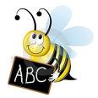
Quarter 3 February 15th
1. Look Look at the word 2. Say Say the word
3. Cover Cover the word 4. Write Write the word
5. Check Check that the word is correct
Spelling Words | Sunday | Monday | Tuesday | Wednesday
1. my
2.first
3. water
4. bad
5. flat
6. grab
7. hear
8. rainbow
Parent sign
6. Challenge yourself Try writing a sentence with a different word each night
Sight words : must new no

