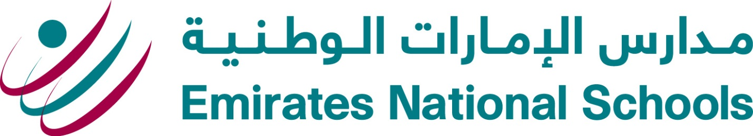
Dear Parents,

We are delighted to invite you to our first 3 Way Conference of this academic year. It will take place on Tuesday 11th November 2014. For those of you who are new to ENS, this conference is different from regular Parent Teacher Meetings as the students will be present. They will discuss their strengths and areas for development. They will set a learning target and both the teacher and the parent will share some ways that they can help support the student’s learning.
In order for the smooth running of the conferences, we are asking that every parent make an appointment with the student’s homeroom teacher by email. Each teacher will post their meeting schedule on their Weebly page. The conferences will last approximately ten minutes and we request that all parents and teachers keep to the allotted times.
National curriculum teachers and Specialist subject teachers will also post a schedule on their Weebly pages. If you would like to make an appointment to meet with them you are more than welcome.
Parents who turn up on the night without an appointment, will be asked to make one for the following week.
This year, report cards will only be sent out in quarters 2 and 4. Parents will be updated on student progress during the Three Way Conference and will take home a progress report from Power school. Please read attached brief from Dr Lynn for more information.
Thank you in advance for your cooperation for this event, I hope it will be a valuable and worthwhile experience for all involved.
Yours sincerely,

Patricia Maher
PYP Coordinator

